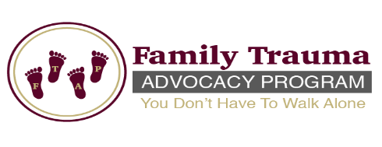
Family Trauma Advocacy Program
GriefTalk Submission Form

Do you have a story you would like to share with other survivors? Do you have a poem that will inspire, or a testimony, or words of encouragement that will uplift a broken heart? We want to hear from you. Please submit a copy of any of the above for review to be posted on our GriefTalk page.

Please complete and email back to ftaprogram@comcast.net (Please type “Newsletter Poem/Story” and name in the subject line or print and mail to:

Family Trauma Advocacy Program
310 Hammes Ave.
Suite 302B
Joliet, IL 60435

Name:

Address: __

City: __ State: __ Zip: __

Contact Number: __

Email: __

Grief Talk Entry:

Please note, to submit a poem or story, please complete the “Photo and Information Release Form.” Additionally, if you would like a picture to accompany your submission an original photo can be submitted (no photocopies please) however, this is not a guarantee that it can be included.

