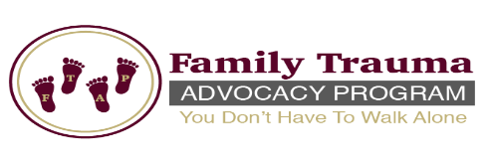
Family Trauma Advocacy Program
Reflection Wall

The Reflection Wall is a display of those who have lost their life to a violent death.

The purpose of the Reflection Wall is to express that each person who died is not just a statistic, or a face; but a person with a name, who has a family, as well as dreams and goals. The wall is a reflection of them so others can see who they were.

Please complete

Family Information

Name: _

Address: _

City: _State: __Zip:

Contact Number: ___Email: _

Deceased Information

Name: _

Date of Birth: _ __Date of Death: _

Cause of Death: _

Write a short paragraph no more than 150 words about your love one.

Please note: To submit a photo, please download and complete the “Photo and Information Release Form.” Additionally, an original photo can be submitted(no photocopies please) via

Email: ftaprogram@comcast.net (Please type “Reflection Wall” and loved one’s name in the subject line)

Mail:
Family Trauma Advocacy Program
310 Hammes Ave.
Suite 302B
Joliet, IL 60435

